Creating Role to enable communication between EC2 & S3

1. Created EC2 instance

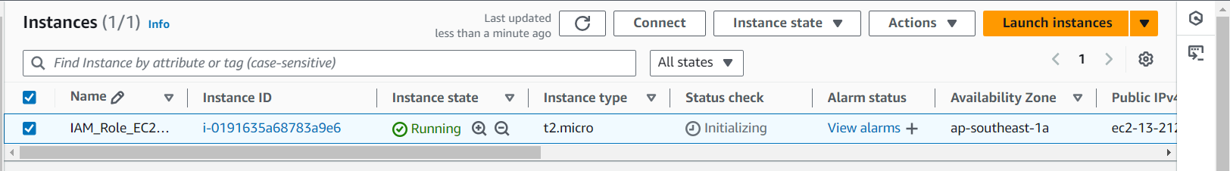

1. Modified IAM role for my EC2 instance

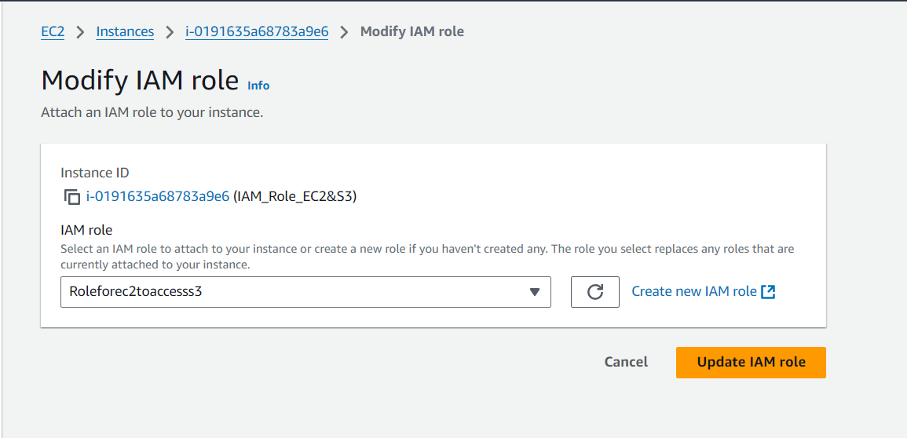

1. Created bucket

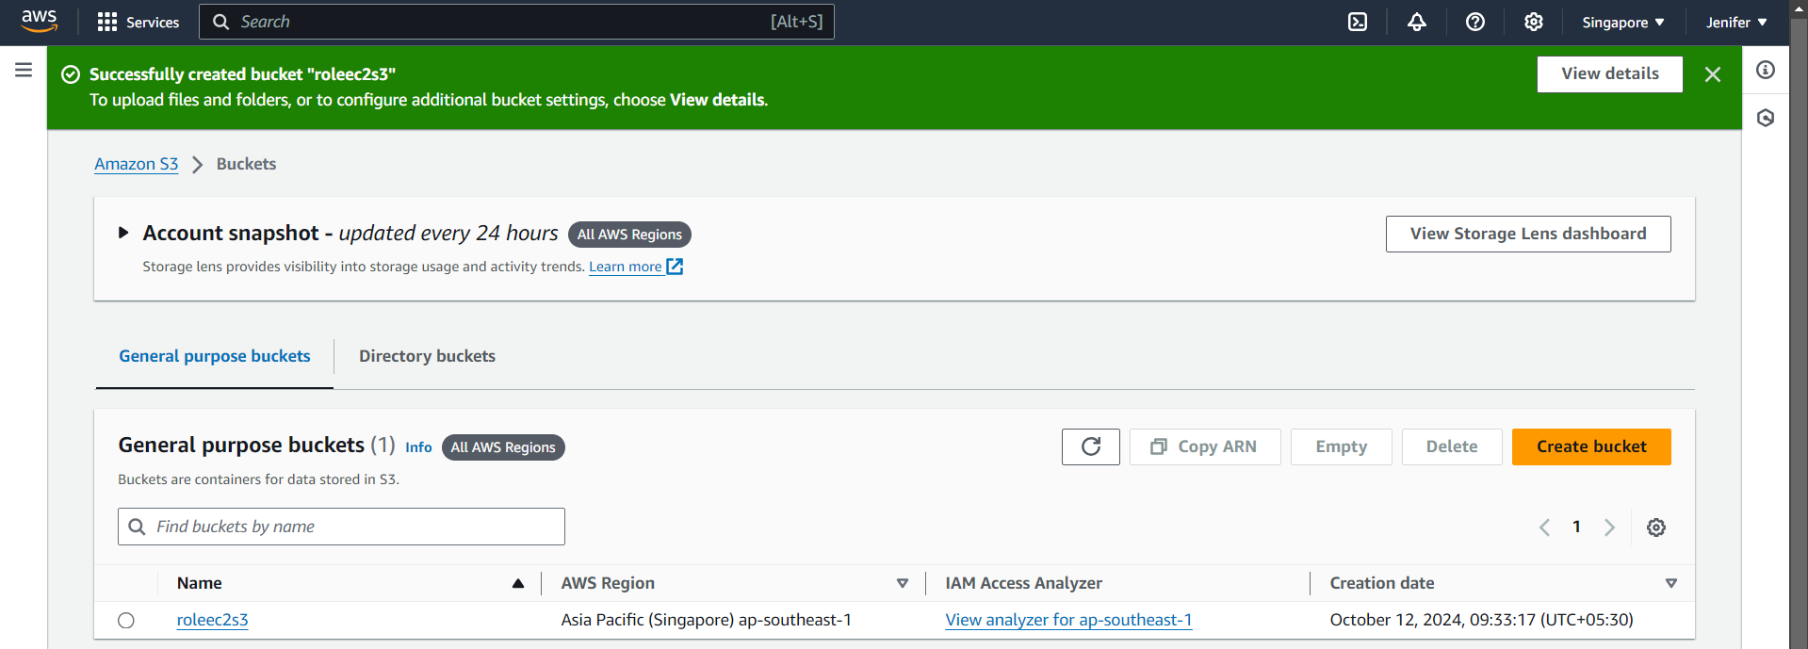

1. Output

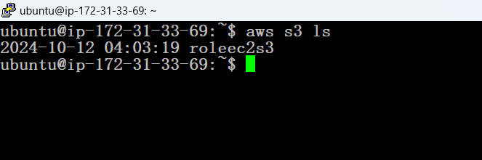

Output for AWS CLI

